Checking the versions of Recipes

Here I have custom receipe.

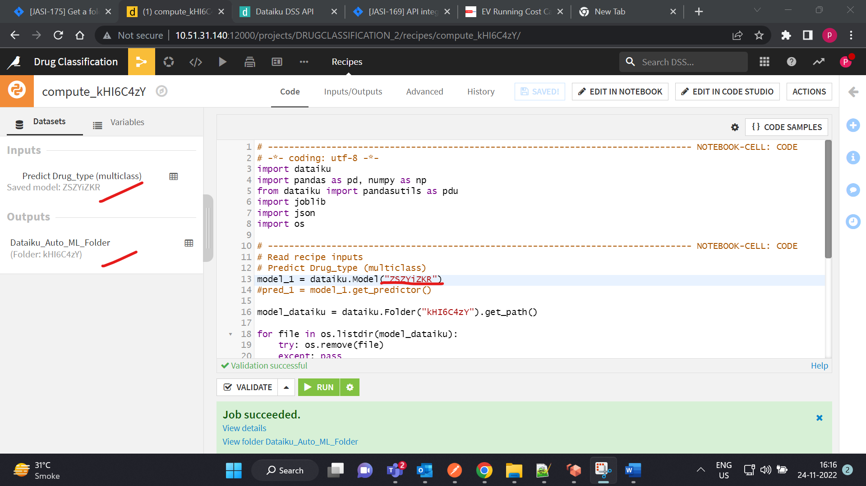

Next, I am running a scenario which I have create previously i.e., Validating Recipes.

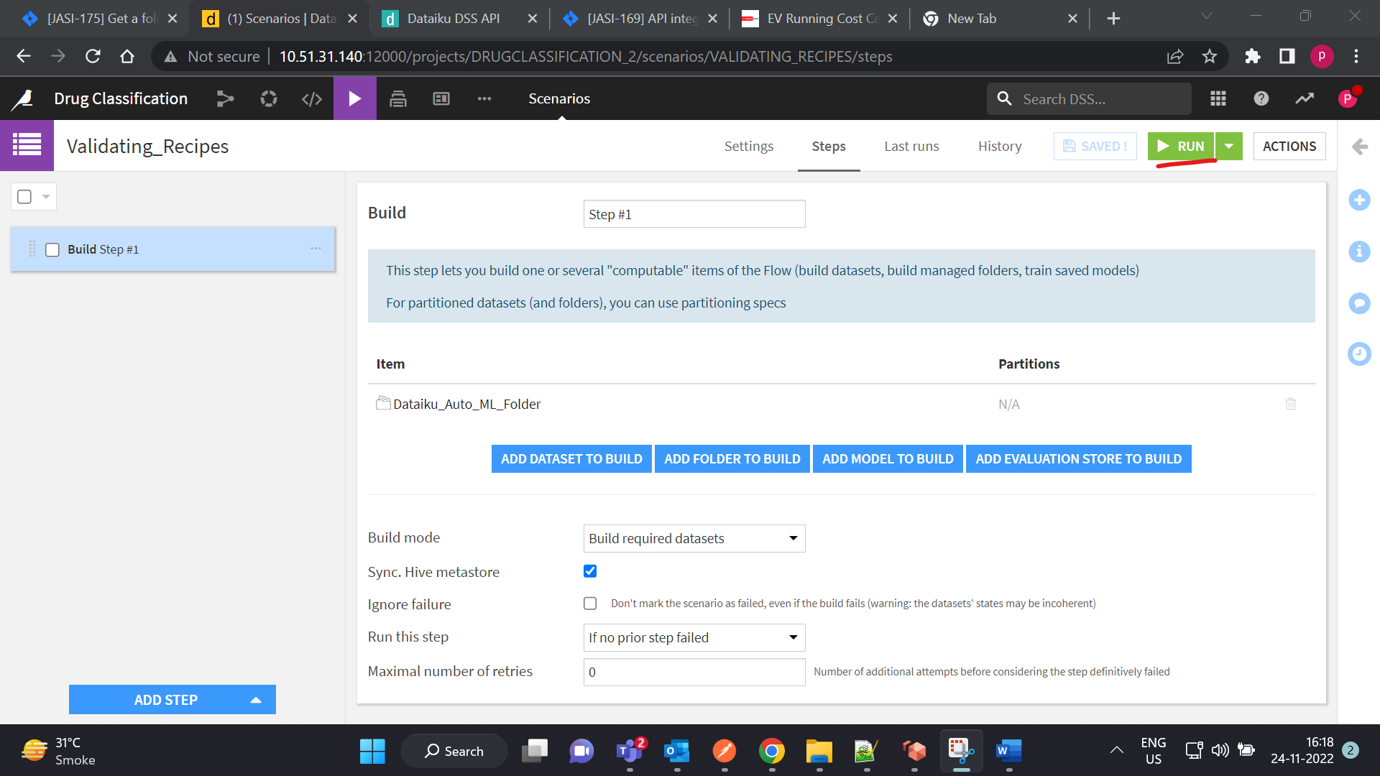

Here if you observe the job get success

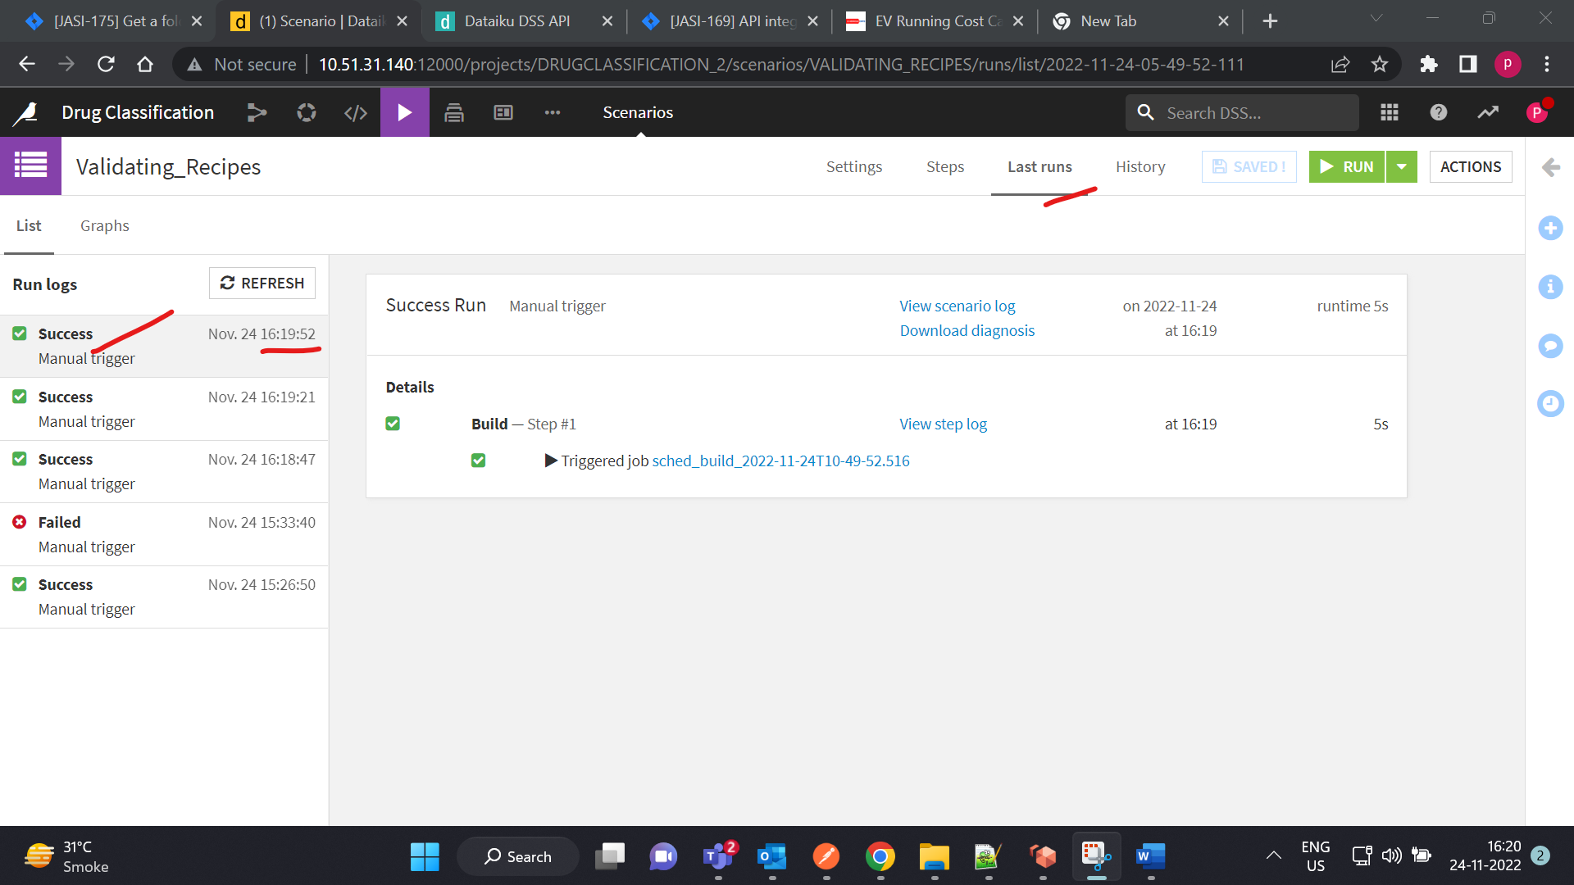

In the next step I am changing custom python recipe and I will run the scenario

Updating the custom recipe and save it

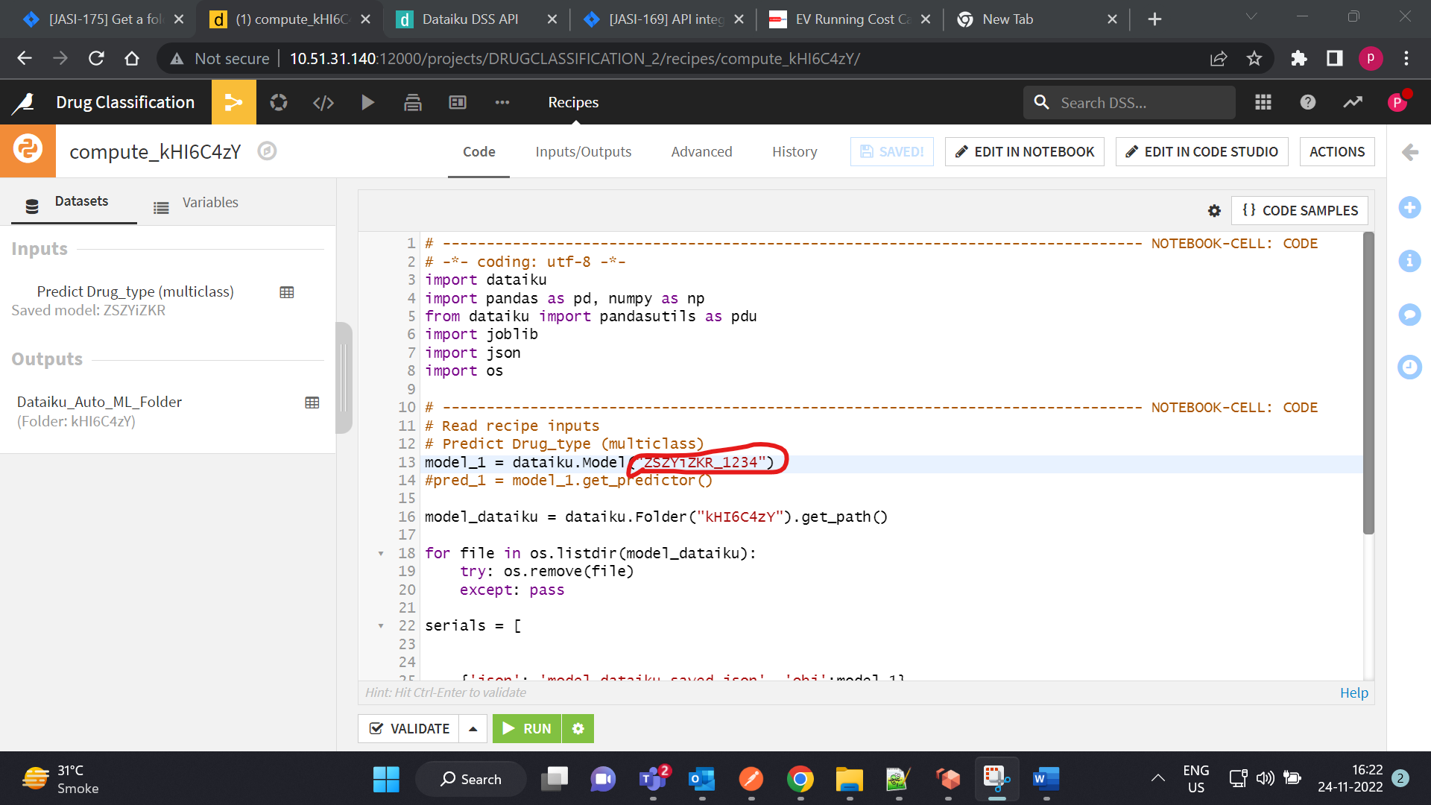

In the next step I will run the scenario but job get failed the changes which I did was not applicable

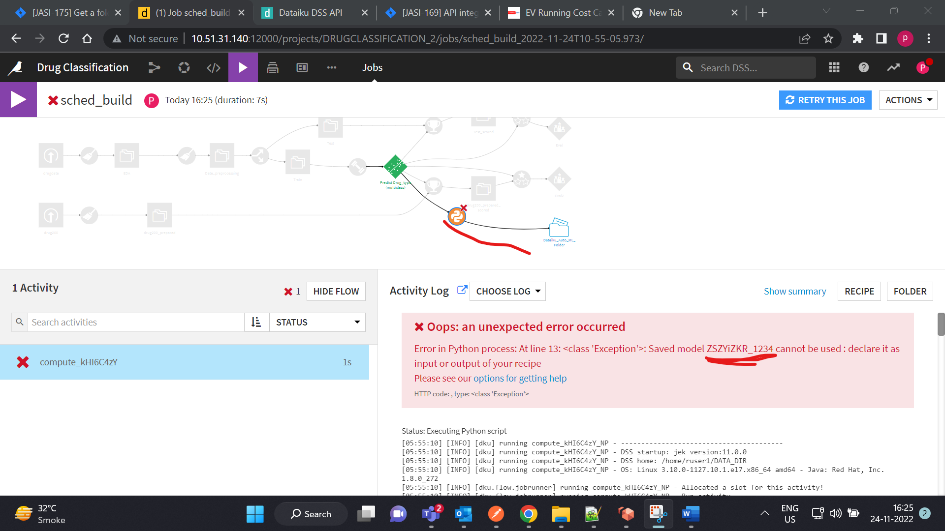

Next I am reverting back to the same version. And job will get successful.

